ML LAB 01 (CS22104)

Q2: 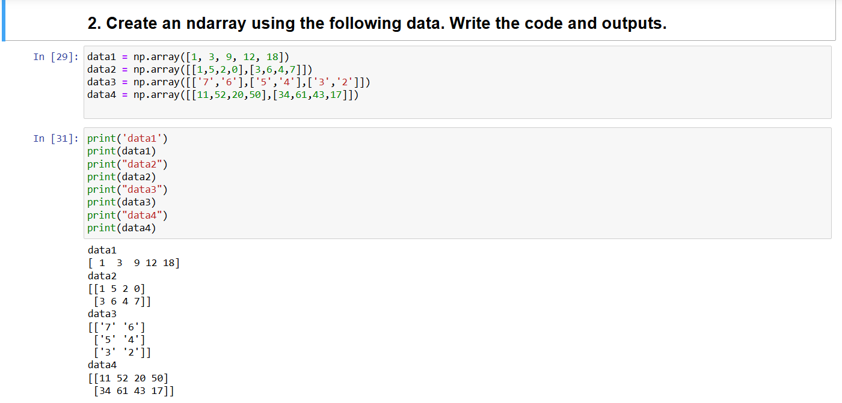

Q3:

Q4:

Q5:

Q6:

Q7:

Q8:

Q9 and Q10:

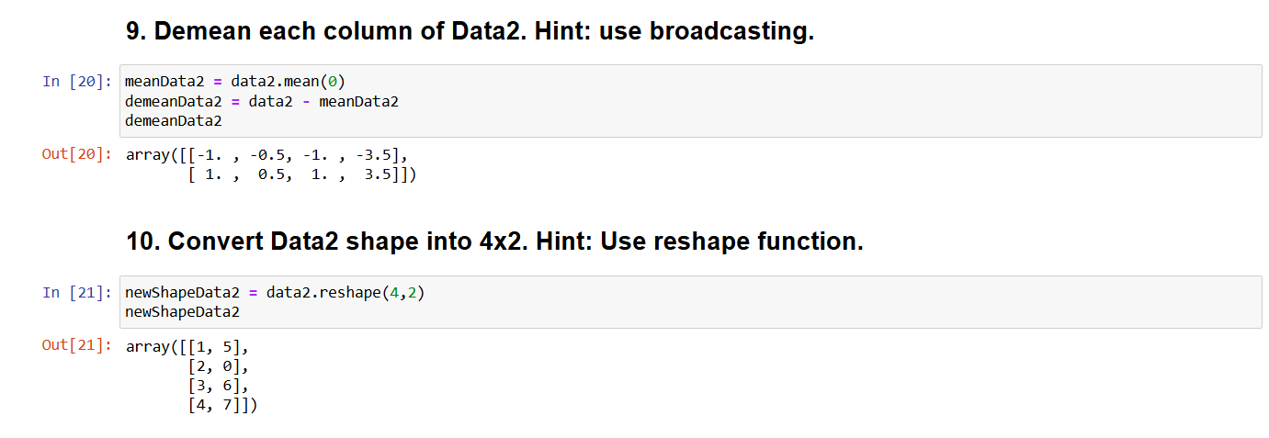

Q11:

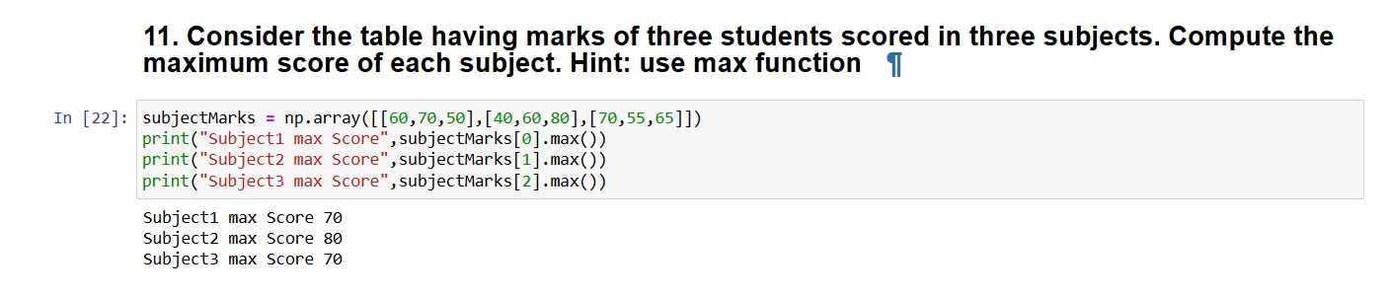

Q12:

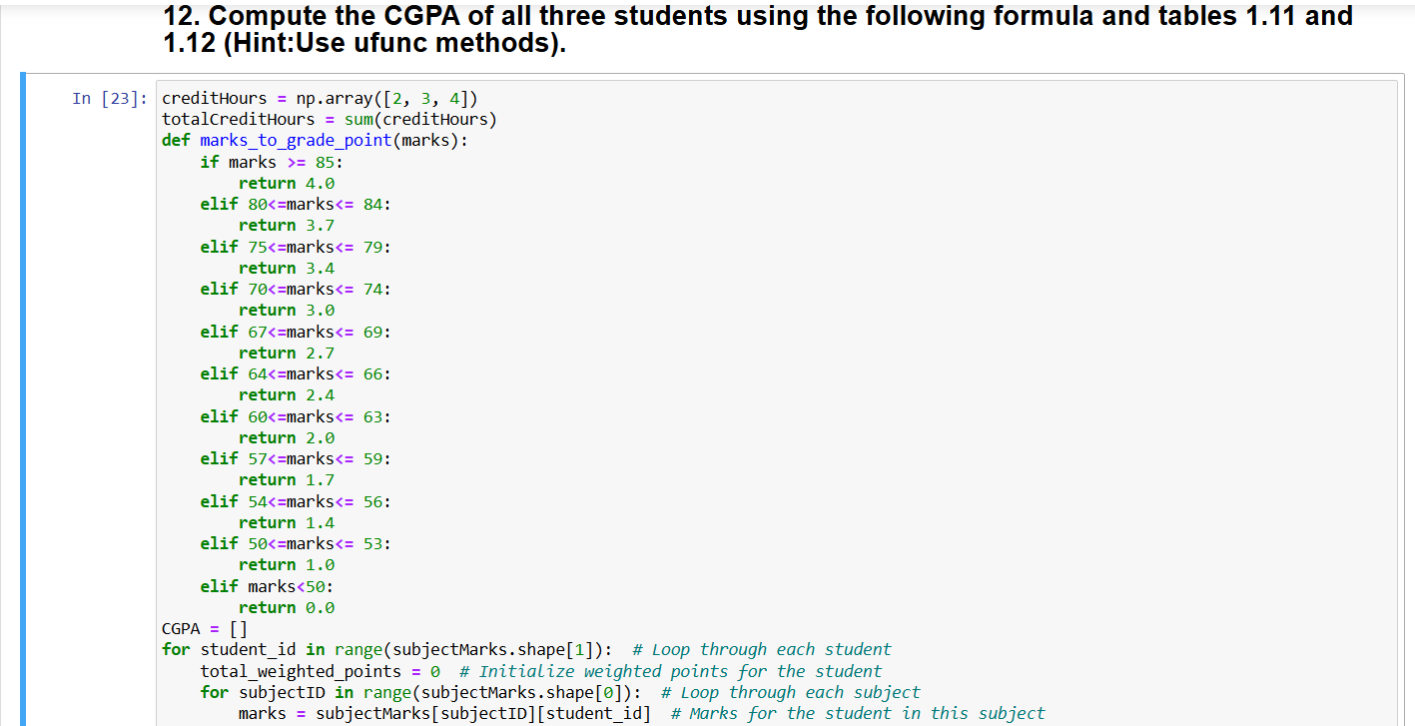

Q13 and Q14:

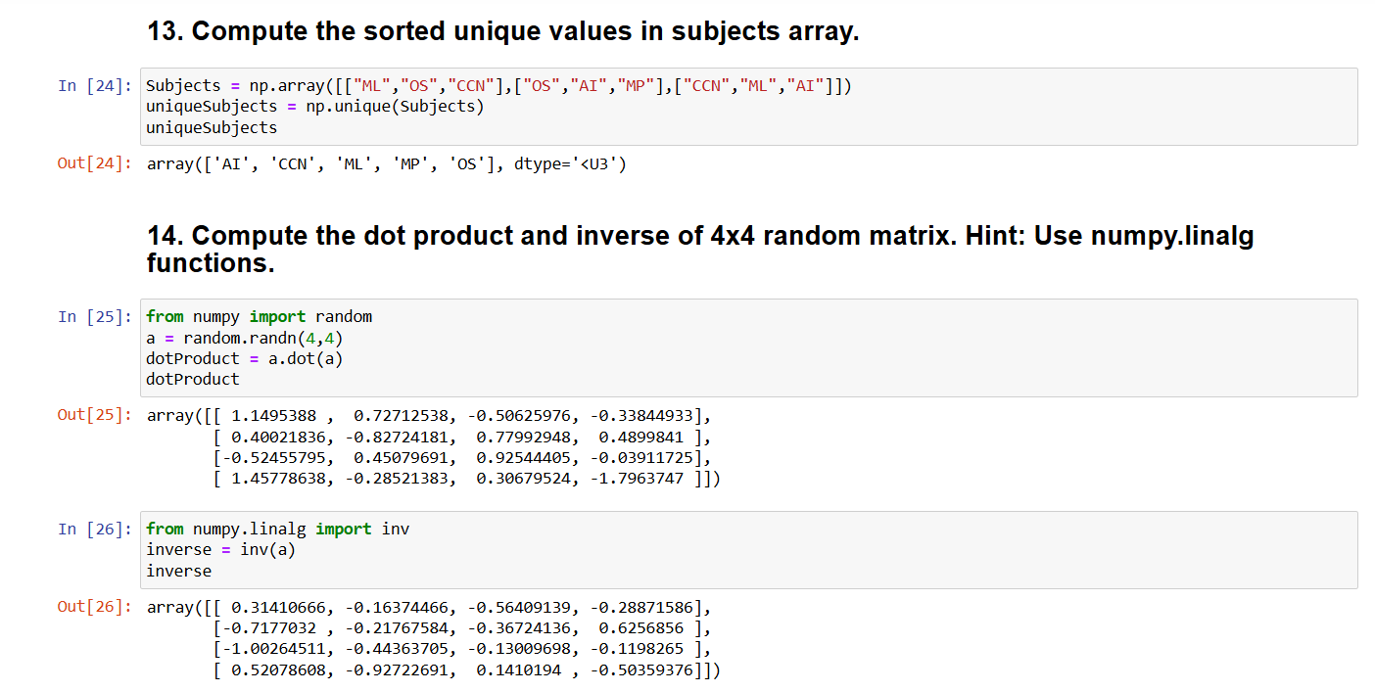

Q15:

